- Check the DATE on computer (can’t be too far off)
- Possibly clear the QM file on the local computer (client; see separate instructions)
- Make sure the QuizMachine version is at least 4.1.x, but 4.1.y29 is better and must be used for Windows 7 and a USB interface box.
- Load QM file using the scoresheet function/”Import Names/Schedules” and that the “Use Imported Names” box is checked.
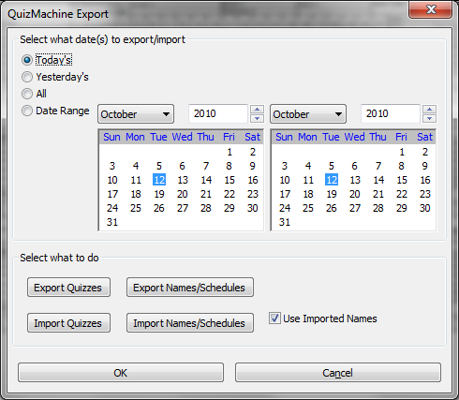
CHECK QM Options (either from Lineups or Setup)
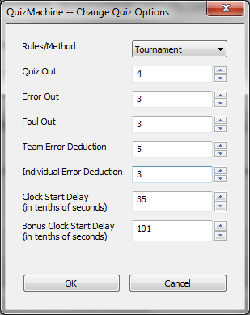
Rules/Method: Tournament (Critical)
Parameters:
Quiz Out = 4
Error Out = 3
Foul Out = 3
Team Error Deduction = 5
Individual Error Deduction = 3
Clocks = leave as is
(the picture below is the default)

ENTER QM “Create a New Quiz” OPTIONS (from Lineups)

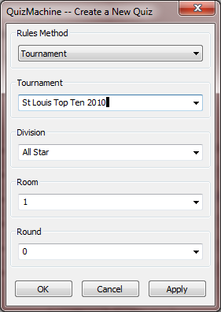
1

Rules Method = Tournament
Tournament = Whatever you want it to be
Division = Whatever you want it to be
Room = 1 (just the room number from 1-xx or whatever you want)
Round = 1 (one; I do not recommend using the schedule part of the file)
Click OK

A message indicating that the previous round was not complete may be displayed. Click OK.

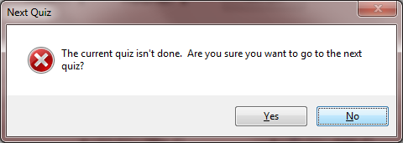

AT THE LINEUPS SCREEN, click next quiz. It should display Round 1 and you should be able to drop down team members. Check the schedule to make sure the right teams are in this room.

From the QuizMachine Properties window, select Server/Sneakernet; make these entries:
- Make sure the “Use Imported Names” box is checked.
- Make sure the “Use the Server:” check box is NOT checked.
- Make sure the “Check in with the Server” is NOT checked.
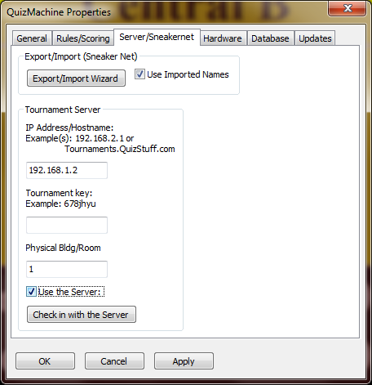

At this point the client computer should be ready.

Clearing files on the client and server before starting; this makes selection of rounds much easier.

For Windows XP the QuizMachine client data base is located in the local hard drive/logged in user/application data/quizstuff/quizmachine4/quizmachine2.sdb ………….The QMServer data base is in the same directory as qmserver2.sdb.

For Windows Vista or Windows 7, the QuizMachine client data base is located in the local hard drive/logged in user/appdata/roaming/quizstuff/quizmachine/quizmachine2.sdb ………….The QMServer data base is in the same directory as qmserver2.sdb.

It is best to have the most current version of QuizMachine (v4.1.y29) that can be downloaded from www.quizstuff.com/downloads

Before you can use the server functions for a quiz you need to load the quizzer and team names. See the format in the attached file as a starter point for your clients.

The QM file is a .csv file (a special spreadsheet file) that has the team name and quizzer names. This is important because it keeps the quizzer names the same from round to round. If you let quizmasters enter the names, they must be typed in exactly the same each round or you will have multiple entries for the same quizzer or team. That why we use a file with names already entered. Load this file on each client computer (again see the attached instructions Computer Setup Instructions).

At the client computers start QuizMachinet and import the names file (with QuizMachine running, click Scoresheet, then Export/Import, then Import Names/Schedules.
To export rounds, the client machine must be running at least Windows 2000 and version 4.1.xx; preferably v4.1.y29. Windows 98 and 95 clients will not work. When a USB key is plugged into the client computer, the QM rounds file should export automatically with a name designated (room number from the create new quiz screen).csv. If it doesn’t export or if you need to export manually this can accomplished by going to the Setup/Exit screen, then Scoresheet then export quizzes.

As rounds are entered, records are being written to a file that must be exported to a memory stick-USB key and brought to the server. It is critical that the QuizMasters understand that the word DONE must be displayed to indicate the round is complete or that round will not export. All ties must be broken or if a round is suspended, use the 5 second button to scroll to the end of the round-DONE must show for the round to be exported in every case.

To set the server, start the program QMServer (in the same start folder as QuizMachine) and first create a new tournament (see server instructions document). On the stats line, right click stats and then add. Give the tournament a name and then click OK. You should now see an entry with your tournament name. You can create multiple tournament names if there are multiple divisions and separate stats are required. Just right click on the stats entry and create as many as are needed. If you expand that entry you should see 4 or 5 entries depending on your version. At this point, you need to import the rounds you have exported from each client. Take the USB key and put it into the server machine and click export/Import on the title line of QMServer. Point the file or files on the USB key (or on the computers hard drive) and all the rounds will import. Next, refresh the file list by clicking the quizzes button again. You should see all the rounds you just imported. Next, highlight each round you want to view by either clicking a single round or using MS windowing selection options using either the Ctrl or Shift keys to make multiple selections at once. A Y will be displayed to the far right side indicating which rounds have been selected. Once the rounds are selected you should be able to see the stats for teams and individuals. You have options on the name of the tournament for sorting by wins/losses, modified Olympic points or Olympic points (again, see the server instructions document). There are also options for 2 team point calculation when mixing 2 and 3 team quizzing.

If you need to correct the spelling of a name, it is best to wait until the end of the day as each time you import quizzes, the names will get messed up again as all the records are imported each time from each round. You can change the name of any team or quizzer by going to the quiz tab and then either teams or quizzers and highlighting the name you wish to change. A window will open with an option to change the name. When you change the name, all occurrences of that name found in the scoresheets will be changed to the new one.

You can also, export, view or print (you will need a printer attached to the server. To export, right click on individual or team (there are other selections for exporting, also). You can export to a txt, csv or html file (HTML is nice for easy posting to a web site).

For individuals, if someone should quiz in a lesser number of rounds than their team, the average is based on the number of rounds for the team not the individual’s number of rounds.

